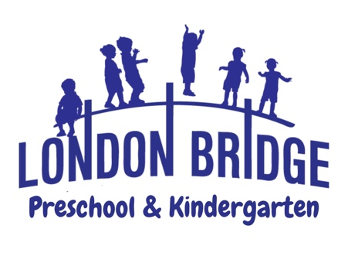
The Toddler’s Program

Young children will begin to learn about their world using their senses. In our Toddler Program, learning will take place with classroom activities that focus on discovery and exploration. Each child will be encouraged to share, take turns, be a good listener and start becoming independent. In many ways, our youngest learners are practicing being members of a structured classroom for future years in school.

Christian Education: Our Christian teachers have a goal; to effectively communicate God’s love for each child. Each day we share Bible stories and talk about God’s beautiful world and all the things He has given us. Your child will be encouraged to pray conversationally, expressing thanks to Jesus for His many blessings. We strive for each child to know that he/she is loved by Jesus and that each was created precious in His sight.

The Program: This program uses a thematic approach to learning. Each month has a different theme with stimulating activities that reflect the theme.

Basic Skill Levels are addressed…

Visual Skills: This is the ability to recognize basic colors and shapes. Looking at books, stacking blocks, building puzzles, sorting objects, and matching colors help to develop this skill.

Auditory/ Oral Skills: This is the ability to complete sentences, follow one-step directions and perform age-appropriate recall. The repetition of puppet play, listening games, and songs are used to develop these skills.

Tactile Skills: This is the ability to identify textures and temperature. Children will be given the opportunity to group objects according to size, color, and shape.

Motor Skills: Gross motor skills are developed through a daily walk and activities in P.E. class either in our fenced-in playground or in a spacious gym; your child will have a place to play no matter what the weather. Fine motor skills are developed within the classroom through painting, gluing, coloring, puzzles and manipulatives.

Social Skills: Your child will be encouraged to use their manners. We will be reinforcing what you are teaching at home. The use of “please” and “thank you” will be emphasized, as well as listening when someone else is speaking. Using words to problem-solve and negotiate will take center stage in the classroom. Social skills should be taught early to kick start a child’s development.

Art: Art is incorporated into the classroom experience through an activity planned by the Art teacher. Creative expression is encouraged. Each child will be “Artist of the Week”. Your child’s art will be displayed in a school-wide Art Show in the spring.

Music: Music is an integral part of a toddler classroom. We will encourage your child to experience the joy of music through participation. Your child will enjoy creative movement and imaginative responses to music through singing, rhythms, and various listening experiences.
Continued on reverse side…

Come make a memory with us at London Bridge Baptist Preschool & Kindergarten! For more information or to schedule a tour, please call the preschool office at 486-7907.

