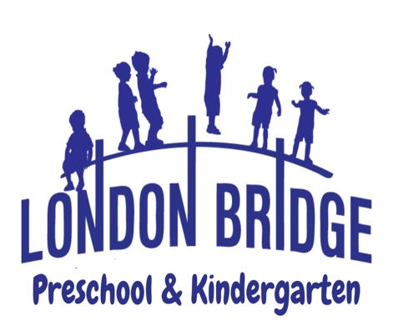
Kindergarten Program

At London Bridge Baptist Preschool and Kindergarten, we view education as a parent-teacher partnership. The teachers welcome any input you may have to share. Our goal is to provide experiences that will satisfy the needs of each child. We encourage each child to grow spiritually, physically, emotionally, socially, and academically. Throughout the year we cover all Virginia Standards of Learning (SOLS) that have been established for Kindergarten students. Higher Order Thinking Skills are used to understand, to infer, to connect, to categorize, and to apply information.

Christian Education: As Christian teachers, our goal is to effectively communicate God's love for each child. Our Bible curriculum is entitled Building on The Rock. Bible lessons provide the children with an opportunity to hear about God’s love. Through our daily lessons, we help each child feel secure in God’s love and encourage them to develop a habit of being thankful for God's beautiful world and all the things He has given us. We strive to increase the child’s ability to make choices between right and wrong through our Bible truths. Once a week, children will attend Chapel in the Worship Center. Chapel lessons consist of object lessons, praise and worship and prayer.

Language Arts: Children will be on the way to reading success with Saxon Phonics and Spelling Kindergarten curriculum. This program correlates instruction for Phonics, Reading, Writing, and Spelling in one unified approach. With a variety of child-friendly material to use, our students will find that learning is fun. Our curriculum encourages children to develop a love for reading and writing by incorporating literature from esteemed children’s authors. For example, February is History Month. Children will complete a book report on a historical American figure. A day will be honored with dressing up as the American figure and enjoying our Patriotic Day.

Science and Social Studies: Science and Social Studies lessons are integrated throughout the curriculum. Some lessons are an extension of the Building on The Rock curriculum, while others relate to the language arts study. Once a month, children will study Science. Students do simple science experiments designed for their age level and that align with the Standards of Learning (SOL) for Virginia Beach Public Schools. During our Science Fair each class will have a display that parents are invited to visit. During the school year weather, plants, insects, force and motion, chemistry and the life cycle are studied.

Mathematics: The Kindergarten Math program combines the “hands on” approach to learning from the Saxon Math curriculum with many traditional “pencil and paper” activities. The children have a wide assortment of manipulatives and games to reinforce the concepts we are teaching. Lessons consist of sorting, classifying, patterns, graphing, counting to 100 by 1's, 5's, and 10's and counting backward. Identifying currency and counting money is part of the math curriculum. Addition, subtraction, measurement, and telling time are also introduced.

Computer Education: Each Kindergarten class is equipped with a Smart Board. This is used to reinforce math and language arts concepts and to familiarize the student with advanced technology and its functions. Children will visit the Computer Lab once a week where they will be instructed through a program provided by Discovery Kids Puterbugs.

Continued on reverse side…

Art: Once a week, children will attend Art Class with the art teacher. Creative Expression is taught through visual, auditory, and kinetic learning styles. Each child will have the opportunity to be “Artist of the Week”. Your child’s art will be displayed at the school-wide Art Show in the spring.

Music: Once a week, children will attend Music Class with the music teacher. This program is designed to help the children experience the joy of music through participation and to motivate a creative and imaginative response to music through singing, rhythms, and listening experiences. Children will participate in a Christmas and Easter program that will be performed for their families.

Homework: Homework is given two or three times per week. Homework is used to reinforce concepts introduced during school. Some homework may consist of children bringing in something special for a class project or to complete larger assignments such as a book report. Children will be asked to memorize a weekly Bible verse which may take some practice at home, also.

Field Trips: Field Trips are scheduled throughout the school year. These trips are taken to enhance the curriculum children are studying and provide a great opportunity for hands-on learning.

Report Cards: Report cards are sent home four times a year: November, February, March, and May. During the first grading period all parents will be asked to attend a parent-teacher conference. Throughout the rest of the year, parents may request a conference with the teacher if concerns arise.

Parent-Teacher Communications: You will receive a monthly calendar and communications as needed to inform you about classroom and school-wide activities. We encourage parents to become involved in LBBP. Parent volunteers are always appreciated during parties and field trips. Working together, parents and teachers can achieve more.

Come make a memory with us at London Bridge Baptist Preschool & Kindergarten! For more information or to schedule a tour, please call the preschool office at 486-7907.

