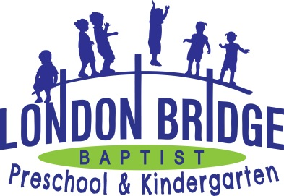
Enrichment Programs

Art

Students will attend a 30-minute art lesson with the art teacher weekly. Students are introduced to different art, artists and art forms through visual, auditory, and kinetic learning styles. The students are given the opportunity to experience and appreciate painting, drawing, sculpture and printmaking with different mediums through age appropriate art lessons.

The Art teacher reserves multiple pieces of art from each student throughout the year for our annual Art Show. Our goal is to provide a positive, fun experience for each child while developing a love for creating.

Music

Students will attend a 30-minute music lesson with the music teacher weekly. Along with the songs and movements used in the classroom, each class will have a musical lesson. Music class introduces pitch, rhyme, playing instruments, creative movement, and rhythm. Music is a wonderful way for each student to express his/her creativity and learn about Gods love for them through song.

Our music programs offer parents special opportunities to see what their children have learned. The Christmas Program teaches the story of Jesus Birth. The Easter Program teaches about Gods love for us through Jesus sacrifice. The Patriotic Festival teaches about the love that we have for God’s country and its leaders. The Pre-K and Kindergarten students will also participate in a Graduation Program at the end of the school year to honor their success.

Physical Education

Students attend 30 minutes of physical education daily with the P.E. teacher. Physical Education is more than playtime and exercise. It also involves agility, balance, cooperation, social skills, gross motor coordination, and following directions. To accomplish these goals, we use a number of tools: the balance beam, ladder, balls, jump ropes, a parachute, hula hoops and tricycles. Game skills are introduced and taught for volleyball, soccer, t-ball and basketball. P.E. areas consist of two outdoor playgrounds and an indoor gym.

