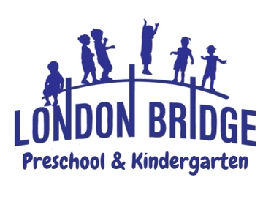
PreK-3s Program

Our three-year-old students express themselves creatively through art, music, drama, modeling, building, and much more. Higher Order Thinking Skills are introduced in large and small groups by making comparisons, classifications, sequencing, patterns, and cause and effect. Along with guided instruction, our three year olds are given time to work on activities that allow for discovery and exploration.

Christian Education: As Christian teachers, our goal is to effectively communicate God's love for each child. The Bible curriculum is designed with three year olds in mind. Each week we read Bible stories that provide opportunities to share with children about God's beautiful world and all the things He has given us. We strive to make the children feel loved. Jesus loves them and so do we. Once a week, children will attend Chapel in the Worship Center. Chapel lessons consist of object lessons, praise and prayer, puppets, skits, and multi-media presentations.

Language Arts: The alphabet letters and sounds are introduced through songs from the Sing, Spell, Read and Write curriculum. Projects emphasizing individual letters of the alphabet help children to connect sounds to letters. Children will begin tracing letters and their names. Show & Tell offers opportunities for children to improve on language skills by speaking in front of a group and speaking in complete sentences. Three year olds begin to foster friendships which involve consciously making good decisions with taking turns, listening to others, and being courteous.

Mathematics: Colors, shapes, opposites, counting, and counting backwards are reinforced through the songs from Sing, Spell, Read and Write curriculum. Children will be introduced to rote counting to ten, recognizing the numbers 1 to 10, counting items from 1 to 10, understanding positional words (i.e. first, last), sequencing, reading graphs, and completing patterns. Hands on activities from the Pre-K Saxon Math along with LBBP’s creative curriculum are intended to actively engage the children with number concepts.

Motor Skills: Art projects for three year olds are designed to exercise small hand muscles. Fine motor development comes through gluing, painting, coloring, cutting, squeezing and pinching. The children attend P.E. class each day which will help to develop gross motor skills.

Art: Once a week, children will attend Art Class with the art teacher. Creative Expression is taught through visual, auditory, and kinetic learning styles. Each child will have the opportunity to be “Artist of the Week”. Your child’s art will be displayed at the school-wide Art Show in the spring.

Music: Once a week, children will attend Music Class with the music teacher. This program is designed to help the children experience the joy of music through participation and to motivate creative movement and imaginative responses to music through singing, rhythms, and listening experiences. Music is a vital piece in acquisition of language and math skills. Children will participate in a Christmas and Easter program that will be performed for their families.
Continued on reverse side…

Science: Once a month, children will study Science. Students perform simple age appropriate science experiments that align with the Standards of Learning (SOL) for Virginia Beach Public Schools. During our Science Fair each class will have a display that parents are invited to visit. During the school year weather, plants, insects, force and motion, chemistry and the life cycle are studied.
Continued on reverse side…
Progress Reports are sent home twice during the school year. Children are evaluated in January and May. Parent-teacher conferences will be requested on an as-needed basis.

Come make a memory with us at London Bridge Baptist Preschool & Kindergarten! For more information or to schedule a tour, please call the preschool office at 486-7907.

