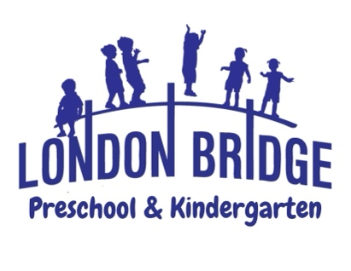
2 ½ Year Old Program

Two-year-old activities are designed for discovery and exploration as well as guided instruction. Students will express themselves creatively through art, music, drama, modeling, building, and much more. Higher Order Thinking Skills are introduced through these activities. Children will learn to share, take turns, be good listeners and become more independent. In many ways, they are learning cooperation.

Christian Education: As Christian teachers, our goal is to effectively communicate God's love for each child. The Bible curriculum is designed with 2 year olds in mind. Each week we read Bible stories of God's beautiful world and all the things He has given us. We strive to show each child how special they are; Jesus loves them and so do we. The children will learn to pray each day by giving thanks and try to memorize one Bible verse each month.

Our 2 Year Old Program uses a thematic approach to learning. Each month will have a different theme with activities that are designed for each to create a stimulating learning environment.

Four Skill Levels are stressed in the program; Visual, Auditory, Tactile and Motor.

- Visual Skills: This is the ability to recognize basic colors and shapes. Looking at books and stacking blocks and sorting help to sharpen this skill. Children will learn to count using concrete objects with a focus on numbers 1-10.

- Auditory/ Oral Skills: This is the ability to complete sentences, follow directions and perform simple recall. The repetition of finger plays and songs are used to develop these skills. The alphabet is introduced with phonics songs from the Sing, Spell, Read and Write curriculum.

- Tactile Skills: This is the ability to identify textures (hard, soft, rough, smooth), temperatures (hot and cold), and group objects according to size, color and shape.

- Motor Skills: The children attend P.E. class each day which will help to develop their gross motor skills with running, jumping, marching, crawling, etc. Fine motor skills are developed within the classroom with painting, gluing, coloring, puzzles, games and an assortment of manipulatives.

Art: Once a week, children will attend Art Class with the art teacher. Creative Expression is taught through visual, auditory, and kinetic learning styles. Each child will be “Artist of the Week”. Your child’s art will be displayed at the school-wide Art Show in the spring.

Music: Once a week, children will attend Music Class with the music teacher. This program is designed to help the children experience the joy of music through participation and to motivate creative movement and imaginative responses to music through singing, rhythms, and listening experiences. Music is a vital piece in acquisition of language and math skills. Children will participate in a Christmas and Easter program that will be performed for their families.
Continued on reverse side…

Science: Once a month, children will study Science. Students perform simple age appropriate science experiments that align with the Standards of Learning (SOL) for Virginia Beach Public Schools. During our Science Fair each class will have a display that parents are invited to visit. During the school year weather, plants, insects, force and motion, chemistry and the life cycle are studied.

Come make a memory with us at London Bridge Baptist Preschool & Kindergarten! For more information or to schedule a tour, please call the preschool office at 486-7907.

