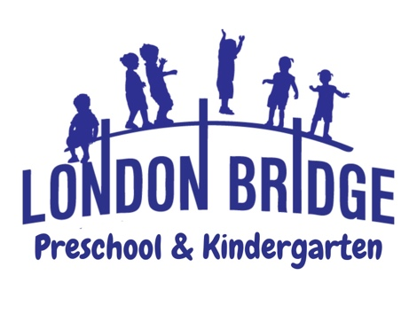
Pre-K-4 Program

Pre-K activities are designed to create a stimulating, well-rounded, learning environment. Students will express themselves creatively through art, music, drama, modeling, building, and much more.
Higher Order Thinking Skills are encouraged through making comparisons, classifications, sequencing, patterns, and cause and effect.

Christian Education: As Christian teachers, our goal is to effectively communicate God's love for each child. Our Bible curriculum is designed with preschoolers in mind. Each week, we read Bible stories to the children and navigate through our Biblical Choices curriculum. We focus on the Old Testament and move into the New Testament, ending the school year with the Fruits of the Spirit and the Armor of God. We are always looking for opportunities to tell the children about God's beautiful world and all the things He has given us. We strive to show each child how special they are. Jesus loves them and so do we. Once a week, children will attend Chapel in the Worship Center. Chapel lessons consist of object lessons, praise and worship and prayer.

Language Arts: Children will benefit from the teaching of the Sing, Spell, Read and Write curriculum and the Saxon Early Learning curriculum. Multi-sensory learning activities, sing-along songs, read-aloud stories, language games, and play activities create effective teaching strategies for Pre-Kindergartners. Children will learn to write and recognize each letter weekly through the Zaner- Bloser hand-writing curriculum. Phonemic awareness is developed through songs, identifying and practicing rhyming words, and recognizing sounds at the beginning and within words.

Mathematics: The Saxon Math curriculum will prepare children by developing skills that will be needed in a more formal setting. Children will be introduced to mathematical terms and will gain an understanding of how math is fundamental in their lives. Concepts that will be introduced are counting, shapes, patterns, calendar, seasons, money, graphing, measuring and personal data.

Motor Skills: Fine motor skills are reinforced through working with manipulatives such as Play-Doh, cutting, coloring, painting, gluing, pinching and puzzles. Gross motor skills are developed through physical education activities. Children will attend P.E. class every day to strengthen and enhance their gross motor skills.

Social Skills: Cooperation, sharing, following rules, communicating thoughts and feelings, helping others and self-control are taught to develop social growth. Each area provides opportunities for learning God's way.

Art: Once a week, children will attend Art Class with the art teacher. Creative Expression is taught through visual, auditory, and kinetic learning styles. Each child will have the opportunity to be “Artist of the Week”. Your child’s art will be displayed at the school-wide Art Show in the spring.

Music: Once a week, children will attend Music Class with the music teacher. This program is designed to help the children experience the joy of music through participation and to motivate a creative and imaginative response to music through singing, rhythms, and listening experiences. Children will participate in a Christmas and Easter program that will be performed for their families.

Continued on reverse side…

Science: Each month students do simple science experiments designed for their age level and that align with the Standards of Learning (SOL) for Virginia Beach Public Schools. During our Science Fair each class will have a display that parents are invited to visit. During the school year weather, plants, insects, force and motion, chemistry and the life cycle are studied.

Computer Education: Once a week, children will visit the Computer Lab where they will navigate the software program, Discovery Kids Puterbugs. This is used to reinforce math and language arts concepts and to familiarize the student with advanced technology and its functions and to develop hand-eye coordination.

Progress Reports are sent home twice during the school year. Parent-teacher conferences will be on an as-needed basis. Children will be evaluated in February and May.

Come make a memory with us at London Bridge Baptist Preschool & Kindergarten! For more information or to schedule a tour, please call the preschool office at 486-7907.

